Gradient Descent for Univariate Linear Regression

We have a hypothesis:
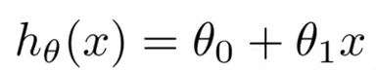

which we need fit to our training data. We can use a cost function such as Mean Squared Error:
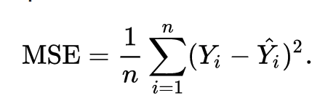
which we can minimize using gradient descent:
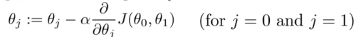

Which gives us linear regression!
